**Load Balancer**

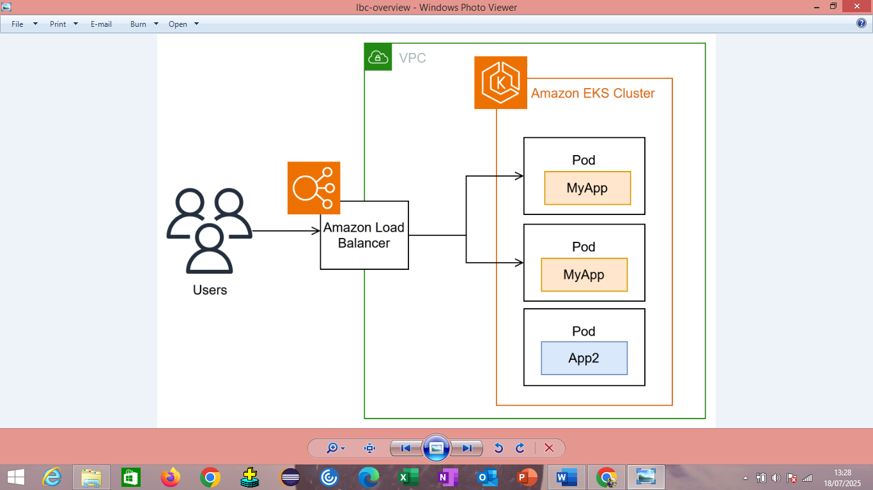

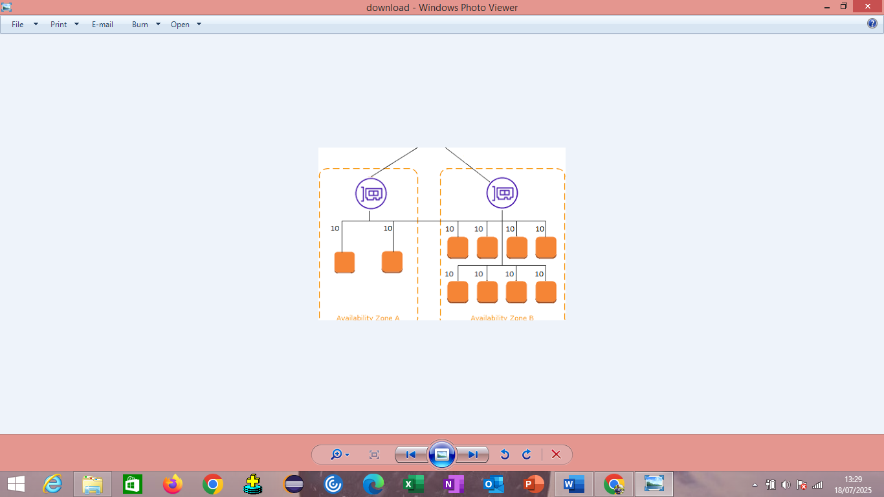

In AWS, a load balancer distributes traffic across multiple targets, like EC2 instances, to improve application availability and reliability. Elastic Load Balancing (ELB) is the AWS service that provides this functionality. There are several types of load balancers in AWS, including Application Load Balancers (ALB), Network Load Balancers (NLB), and Gateway Load Balancers (GLB).

🔹 **Step 1: Launch EC2 Instances**

Before you create a Load Balancer, you need at least **2 EC2 instances** running a web server (Apache, Nginx, etc.).

• Go to **EC2 → Instances → Launch Instances**

• Choose **Amazon Linux 2 / Ubuntu**

• Install a basic web server:

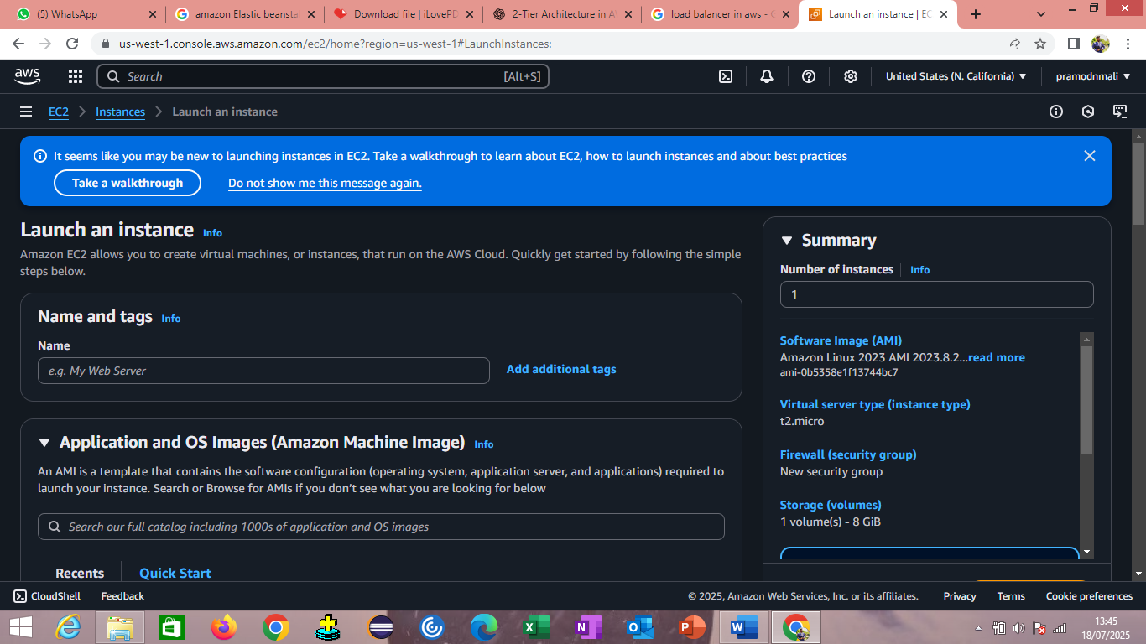

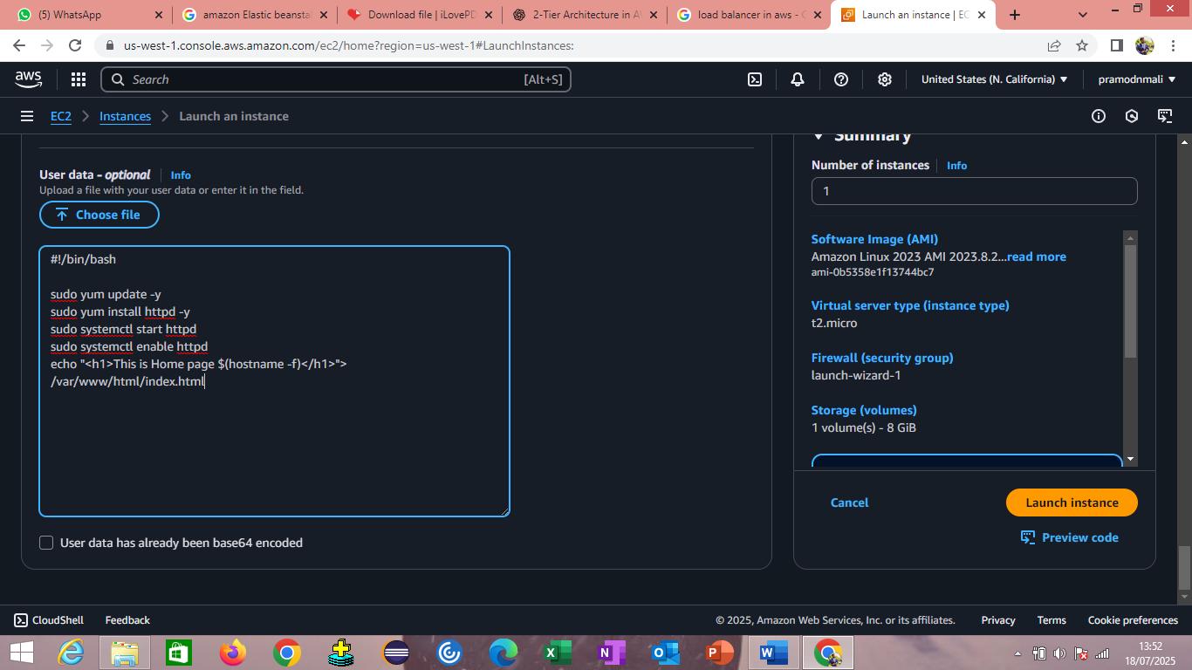



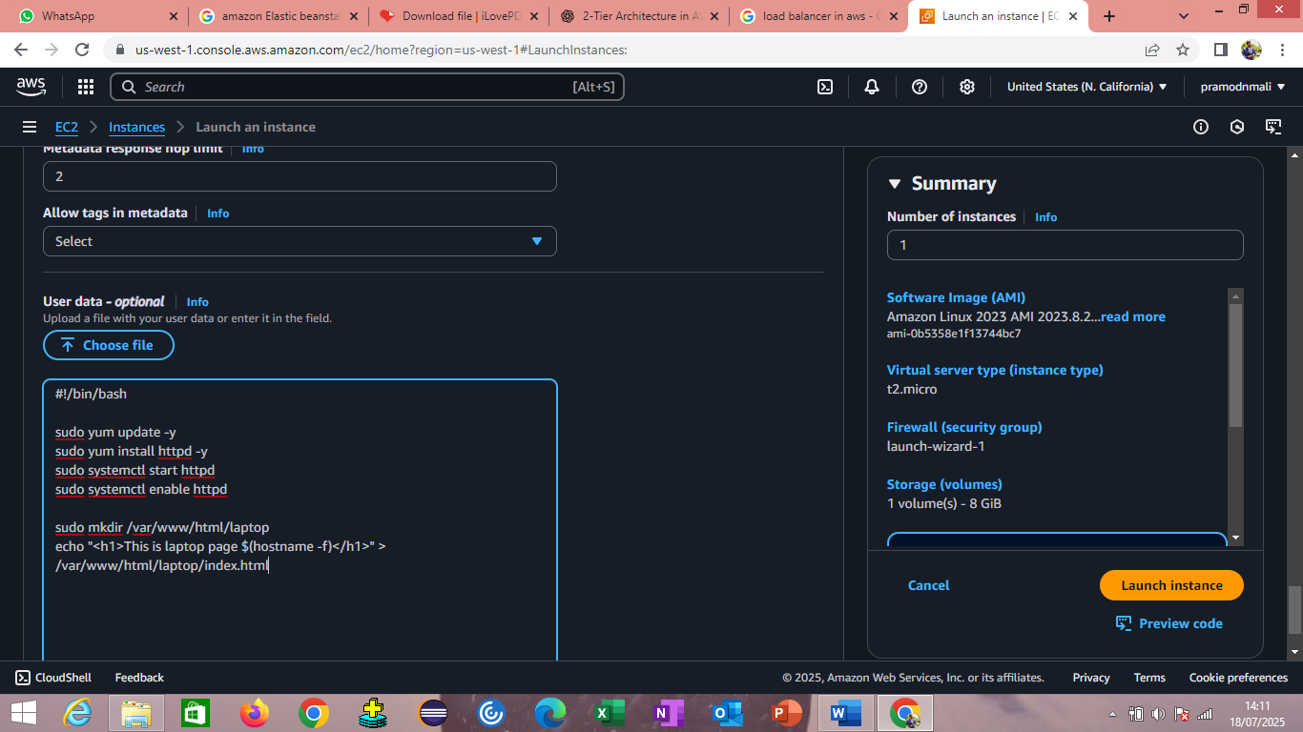

**🔹 Step 2: Open Ports**

Make sure **port 80 (HTTP)** is open in the EC2 **Security Group** for incoming traffic.

#### 🔹 ****Step 3: Create a Target Group****

1. Go to **EC2 Dashboard → Target Groups**
2. Click **Create target group**
3. Choose:
   * **Target type:** Instances
   * **Protocol:** HTTP
   * **Port:** 80
4. Name your group (e.g., my-target-group)
5. Register your EC2 instances with the group
6. Click **Create**

#### 🔹 ****Step 4: Create the Load Balancer****

1. Go to **EC2 Dashboard → Load Balancers**
2. Click **Create Load Balancer**
3. Choose **Application Load Balancer**
4. Fill in:
   * Name: app-LB
   * Scheme: **Internet-facing**
   * IP Type: IPv4
   * Listeners: **HTTP on port 80**

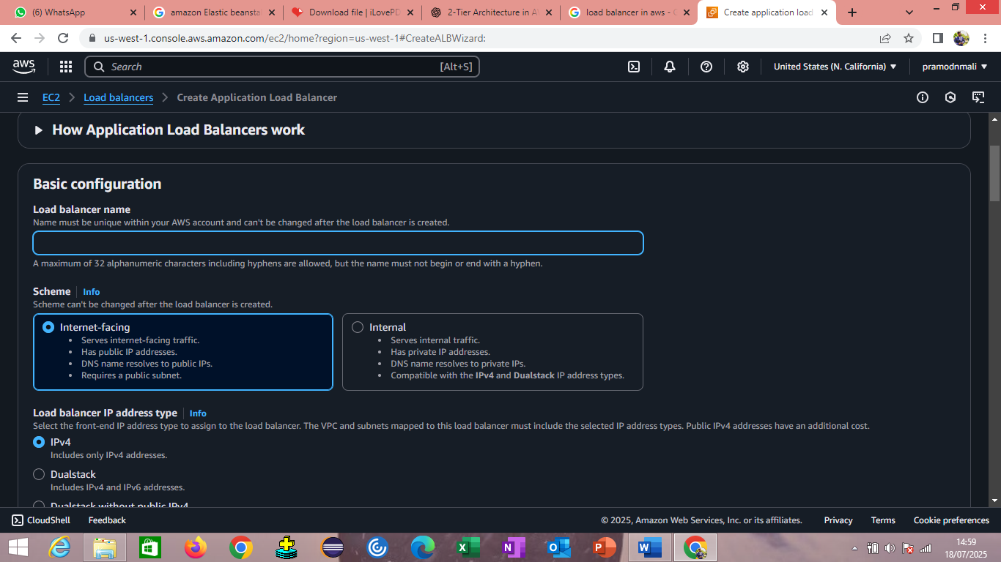

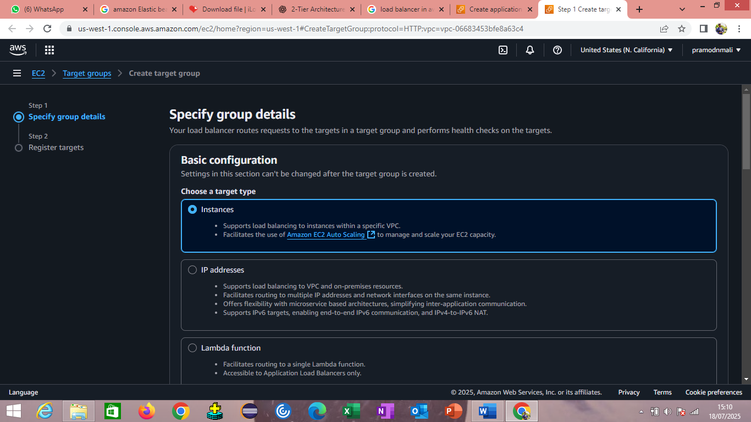

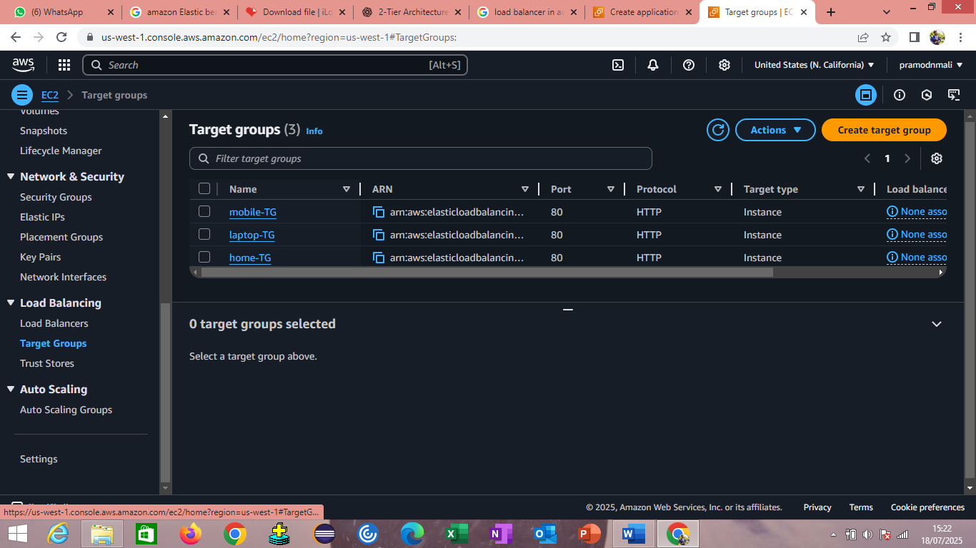

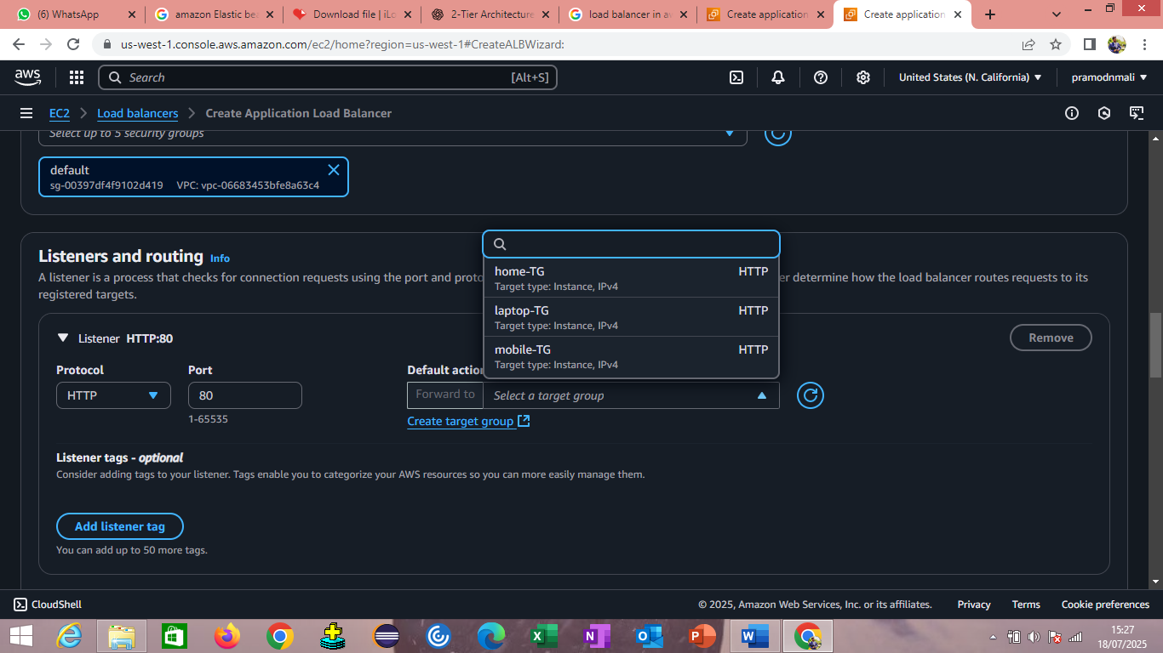

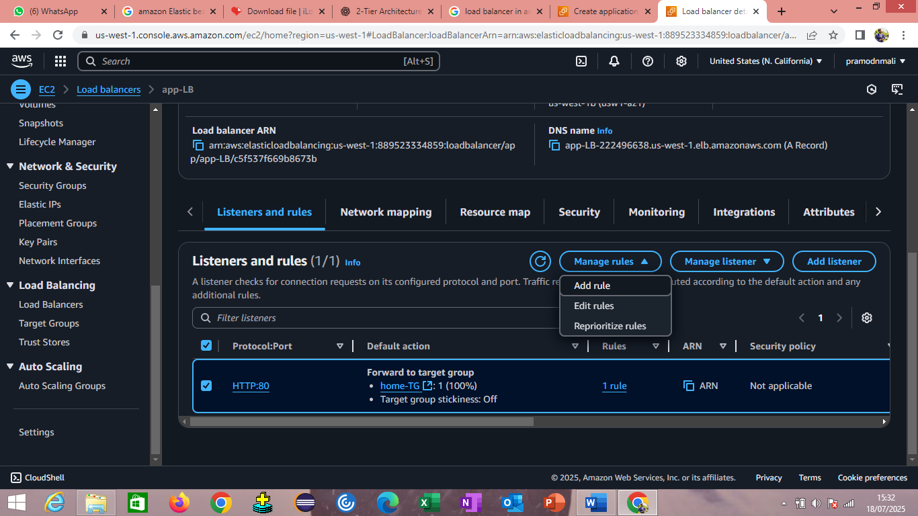

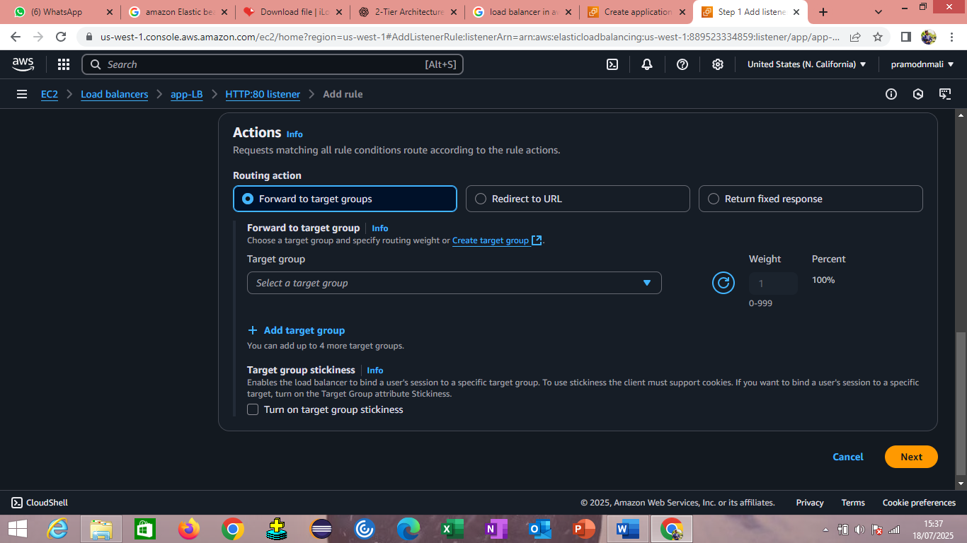

#### ****Step 5: Configure Security Group****

1. Create or select a security group that allows:
   * **Inbound:** HTTP (port 80)
   * **Outbound:** All traffic

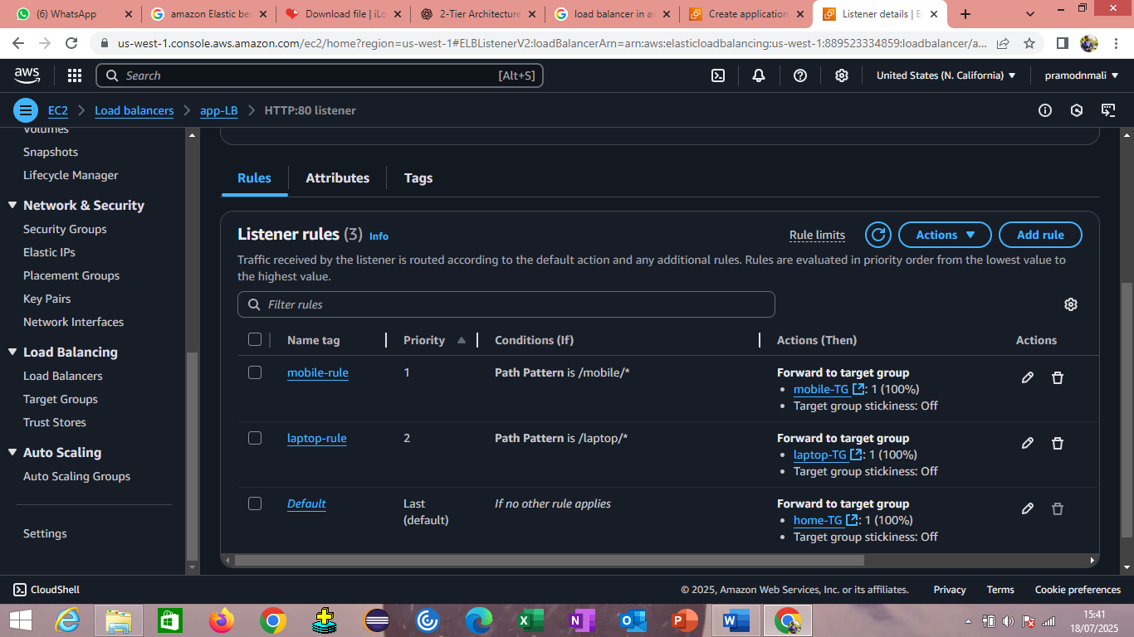

**Step 7: Test the Load Balancer**

* After creation, you'll get a **DNS name** like:

perl

CopyEdit

my-alb-1234567890.us-east-1.elb.amazonaws.com

* Open it in a browser. Refresh a few times — you should see responses alternate between:
  + Web Server 1
  + Web Server 2





**Advantages of LB**

Load balancers improve application performance by increasing response time and reducing network latency. They perform several critical tasks such as the following: Distribute the load evenly between servers to improve application performance. Redirect client requests to a geographically closer server to reduce latency.